Item Description | Qty
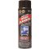  QuestSpecialty 206190001-20AR FOAM PLUS Super Cling Oven Cleaner - 19 oz. Aerosol  Manufacturer : QuestSpecialty  SKU : 1955 | 2
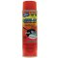  QuestSpecialty 11219DC01-DISP Carbon-Off! Heavy Duty Grease/Carbon Remover - 19 oz. Aerosol  Manufacturer : QuestSpecialty  SKU : 1945 | 3
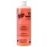  3M Purification 701 Scotch-Brite Quick Clean Griddle Liquid 1 qt. / 32 oz.  Manufacturer : 3M Purification  SKU : 1978 | 1
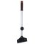  Chef Master 90220 Dual-Handle Griddle Scraper 32"  Manufacturer : Chef Master  SKU : 248097 | 1
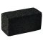  ACS GB12 Scrubble GRiLL-BRiCK Black Grill Brick Grill Cleaner 8" x 4" x 3-1/2"  Manufacturer : ACS Industries  SKU : 1929 | 2

